

**Guru Nanak Dev Engineering College,**

**Ludhiana**

**Web Technologies**

**4 Week Training**

**Project File**

**Submitted by-Rohit Aggarwal**

**CSE-B1**

**U.R.No.-1905039**

**C.R.No.-1915064**

**Luxury Hotel website**

**Abstract**

This project contains a website created with HTML, CSS, BOOTSTRAP,

JAVASCRIPT. Luxury Hotel is a hotel website in which you can view hotel rooms, book rooms. It contains a total of 7 pages – home, rooms, blog, blog-single, about, contact, book now. The project is fully functional in every kind of device whether its phone, tablet or desktop.

**Home**

Home page is the first page of the website which contains the valuable

content like links for other pages such as about, services, case study,

blog, contact. It contains navbar which directs user to their source

and also have many concepts of html like button, links etc. In this project home page will have links to go to booking room page and some layouts of the hotel rooms which customer would like to book into.

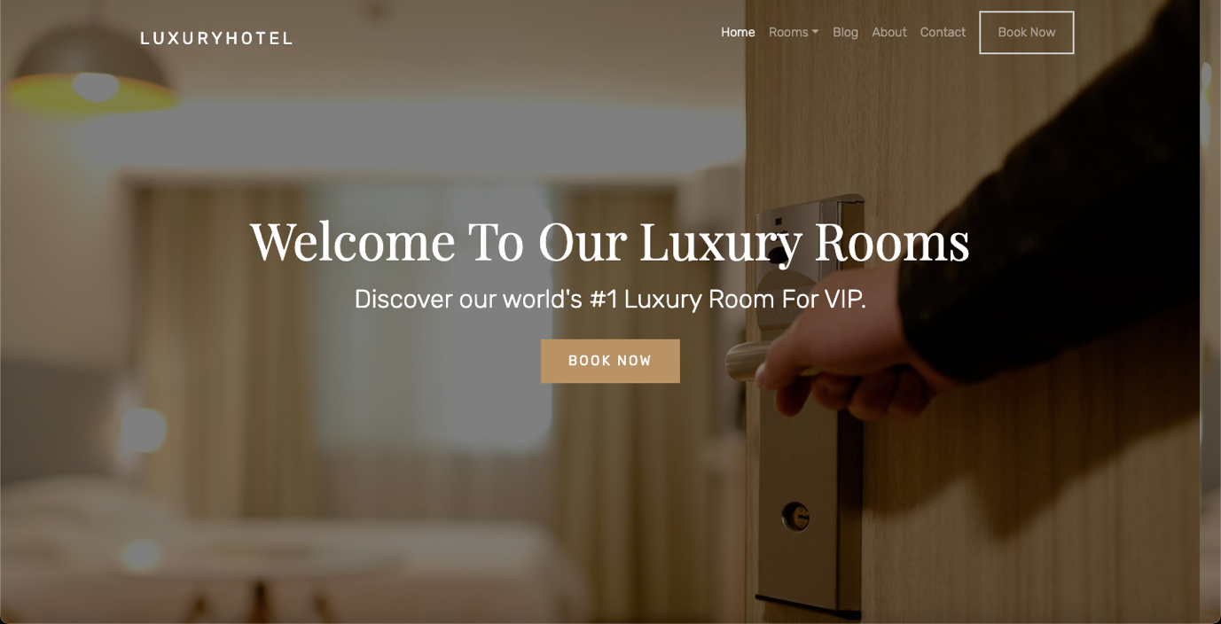

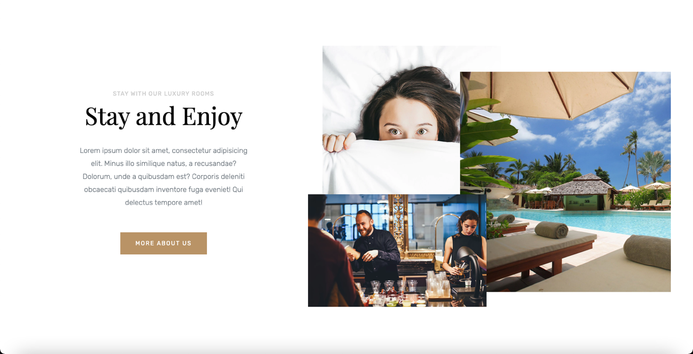

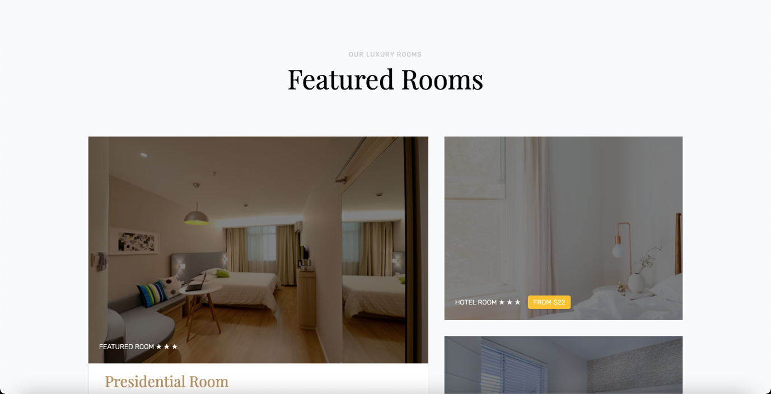

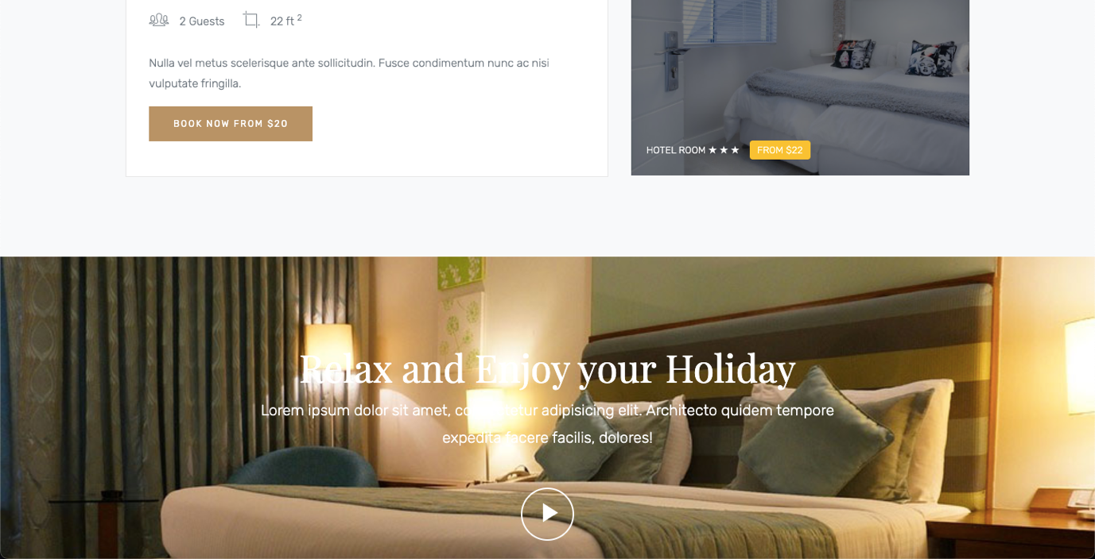

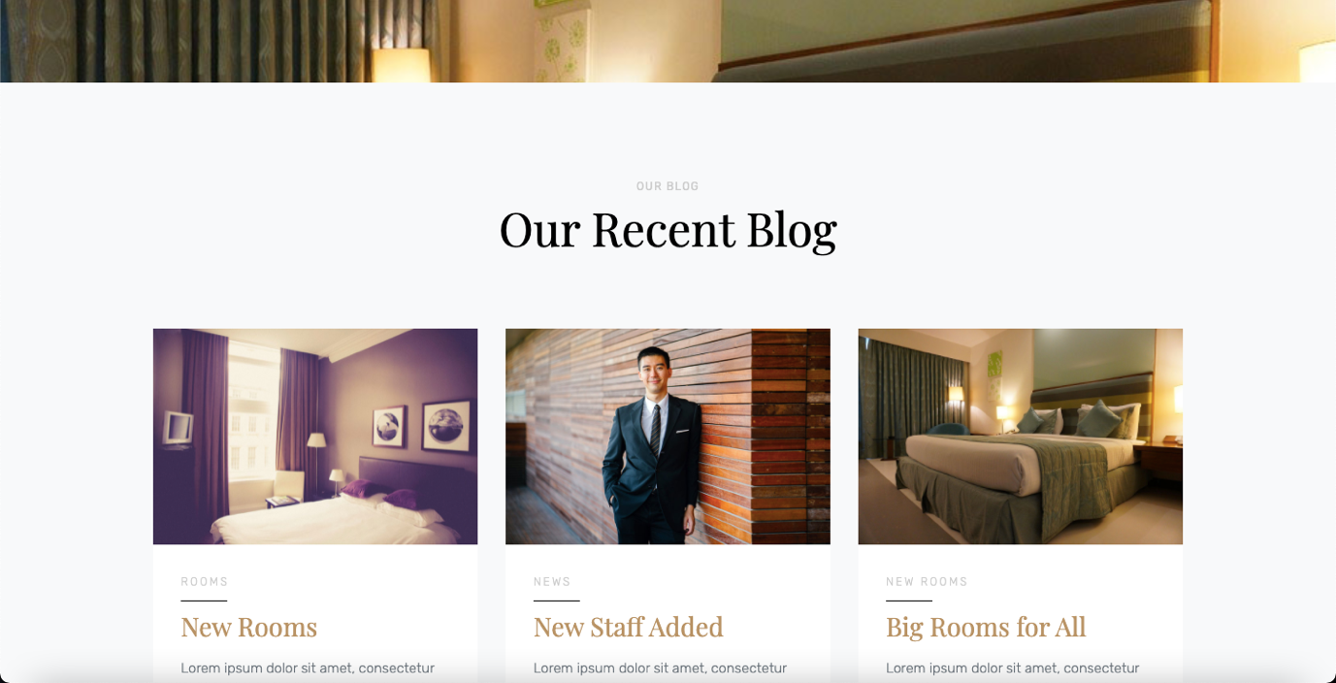

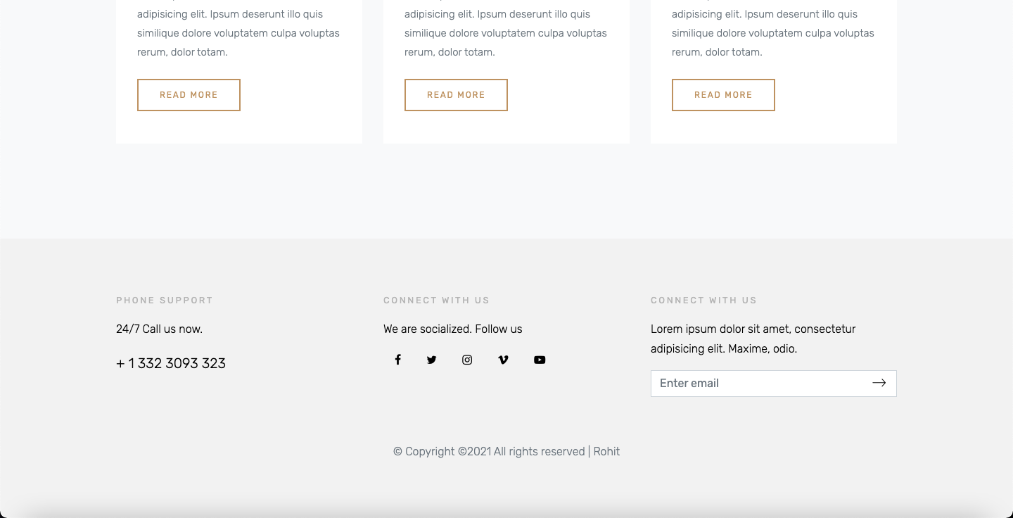

**Rooms**

Rooms page contains the detailed information about the price and view and space of the rooms with their pictures and videos. It also involves ratings from the previous customers about the rooms.

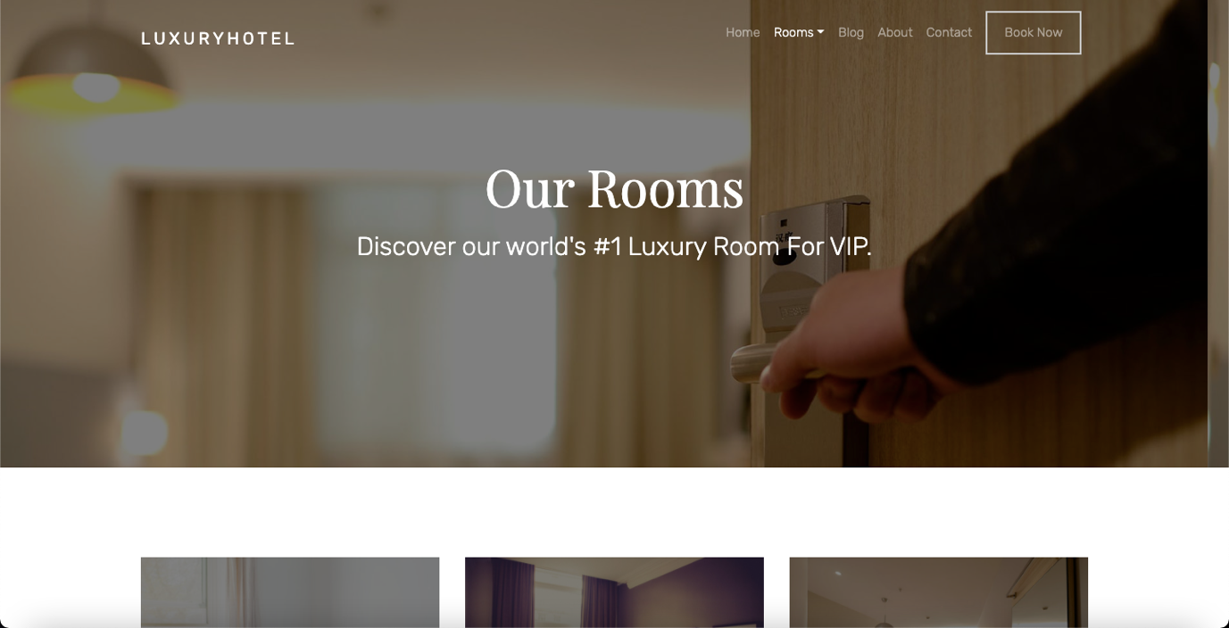

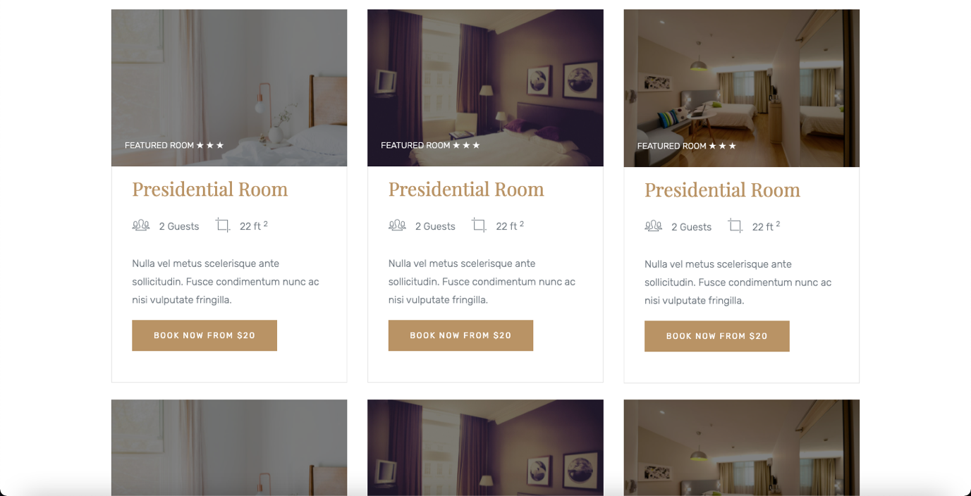

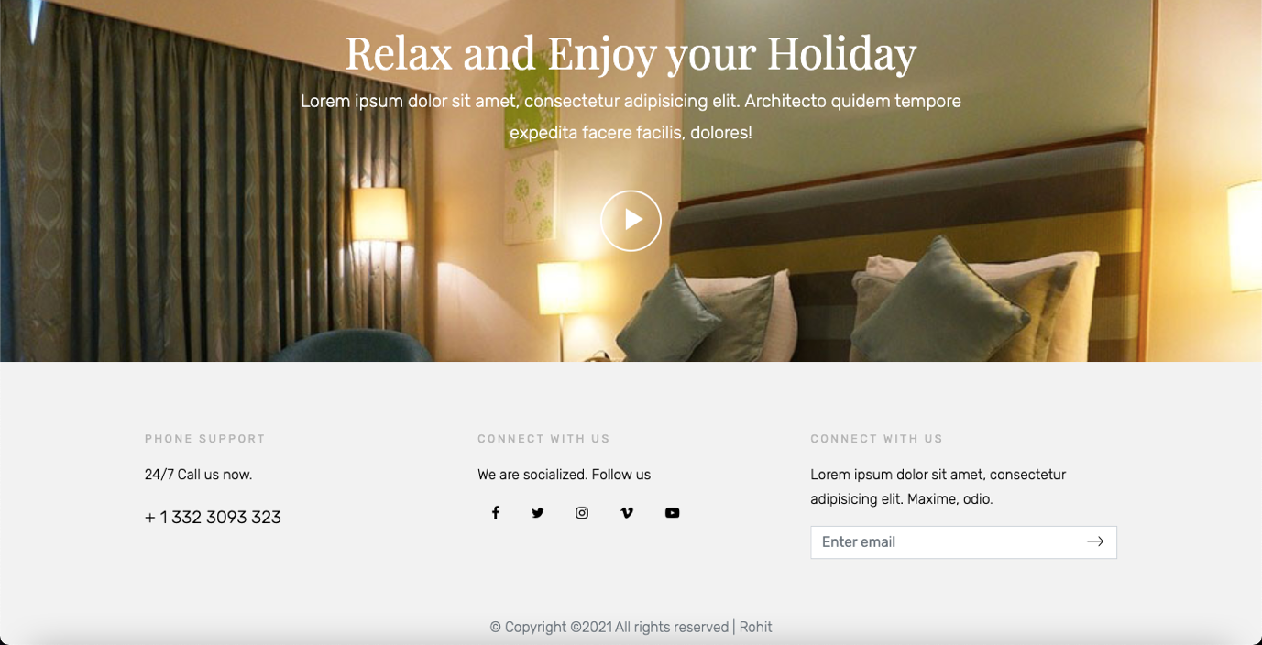

**Blog**

The blog page contains the various blogs posted by previous customers and bloggers about the hotel and their experience in it.

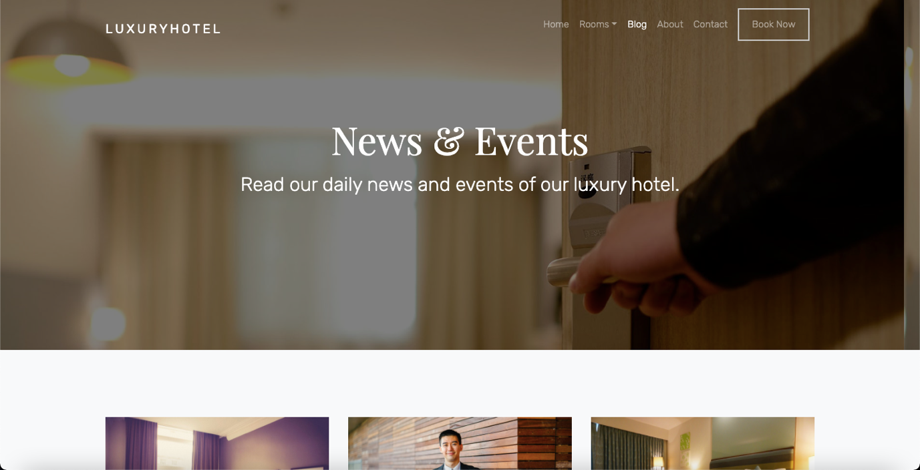

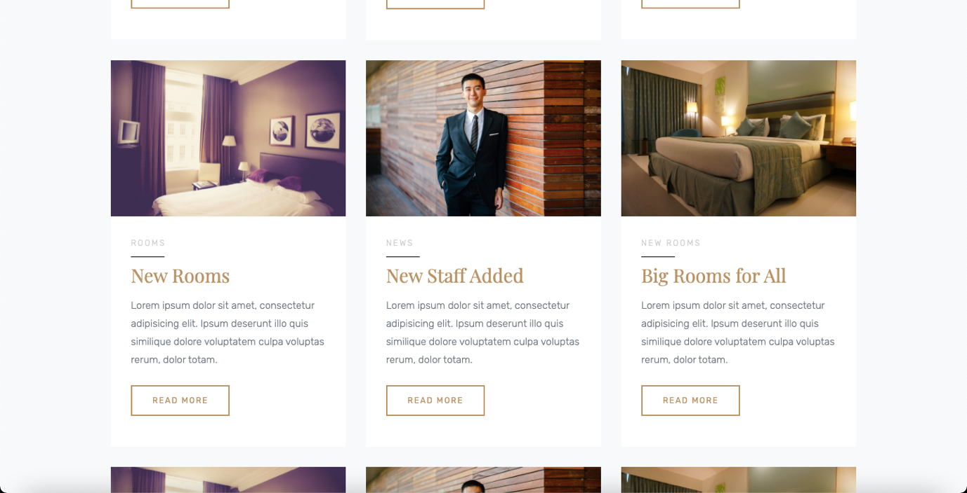

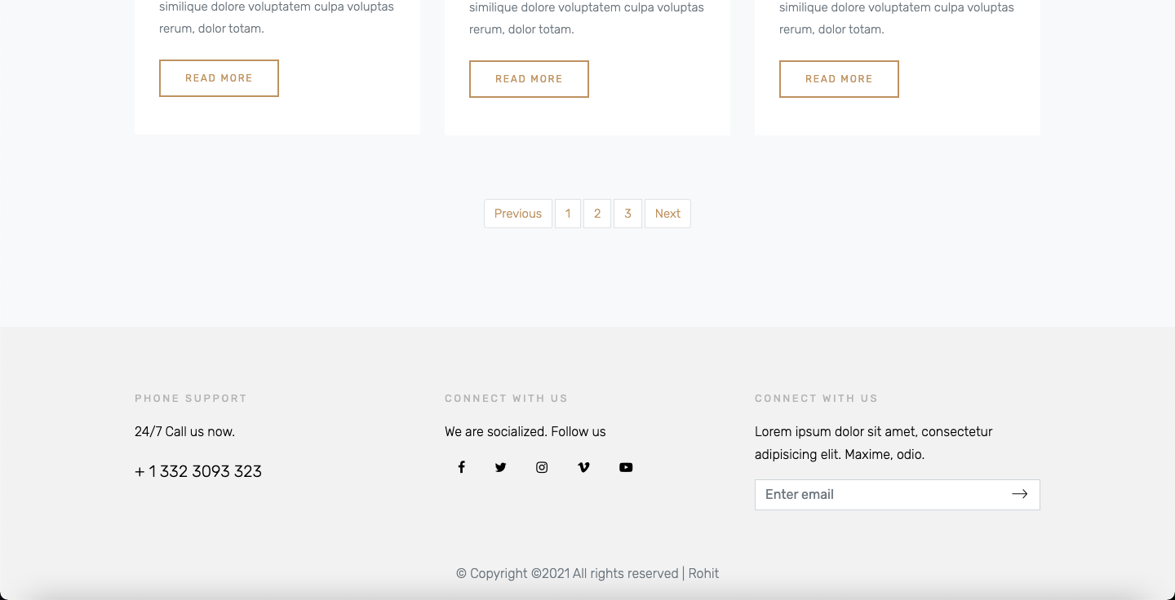

**Blog-single**

Among the array of blogs, user can view a single blog when clicked on.

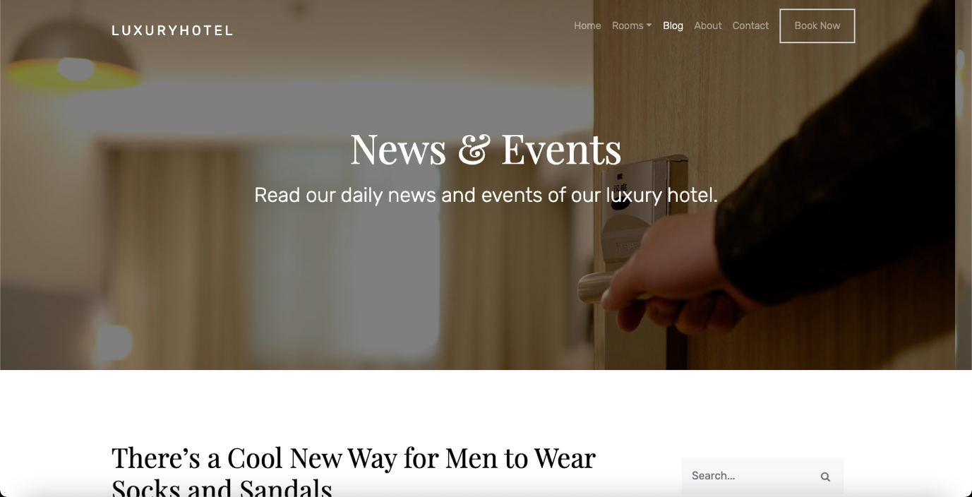

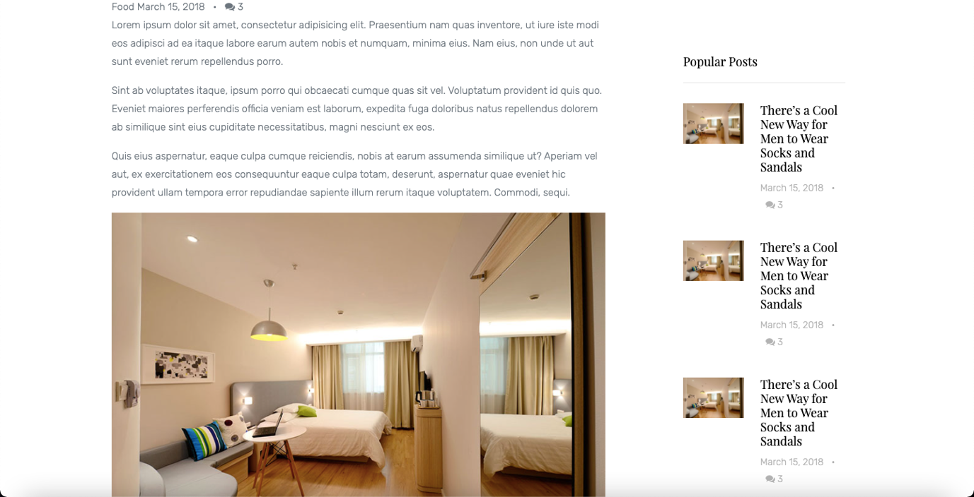

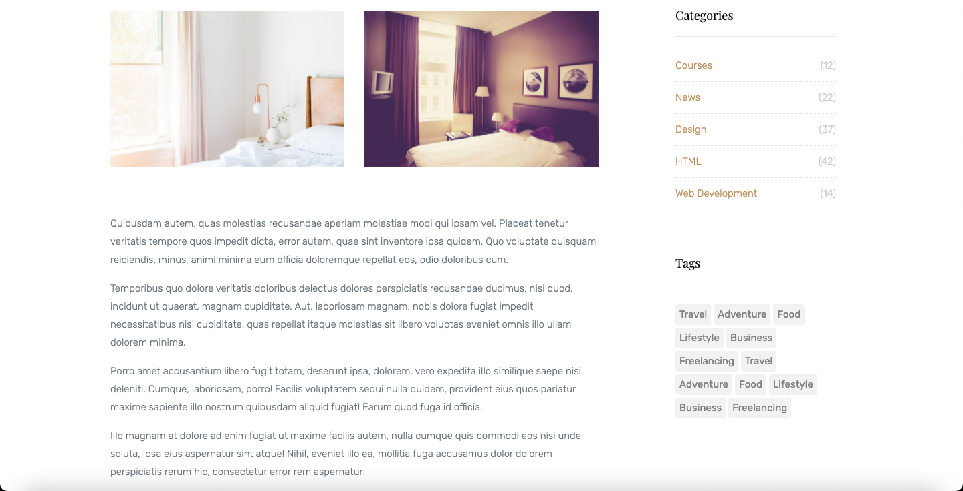

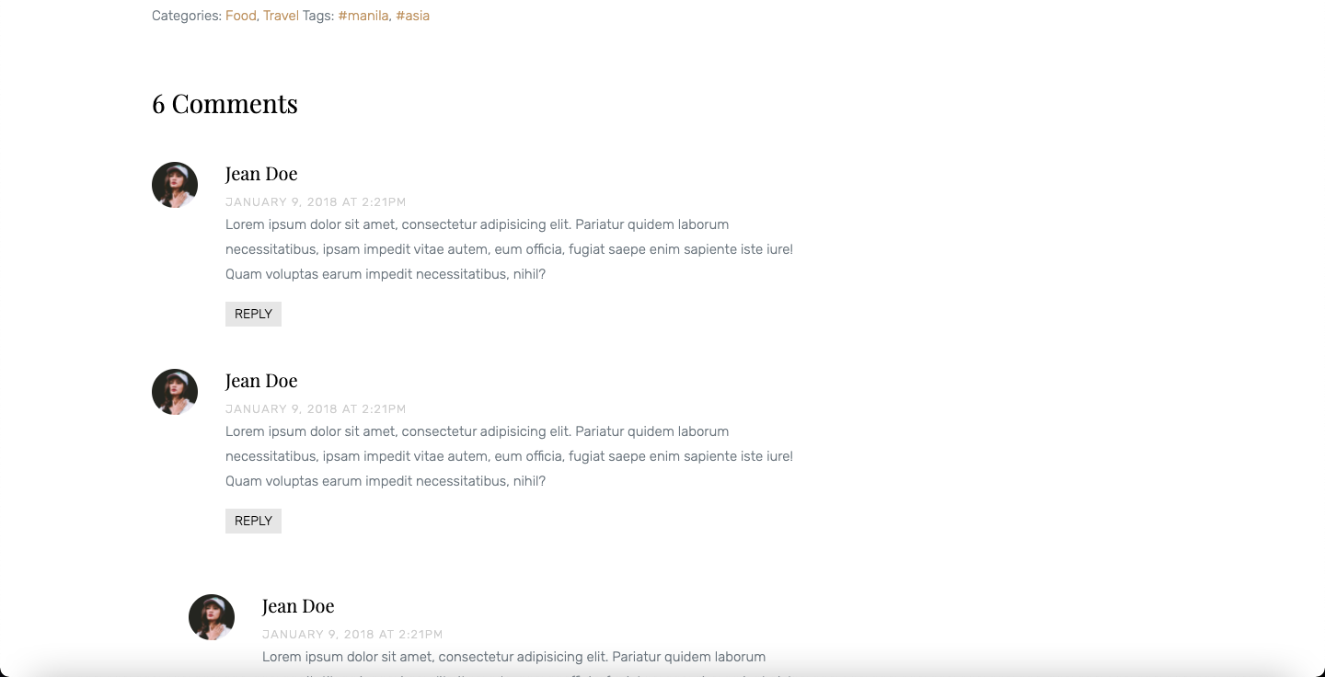

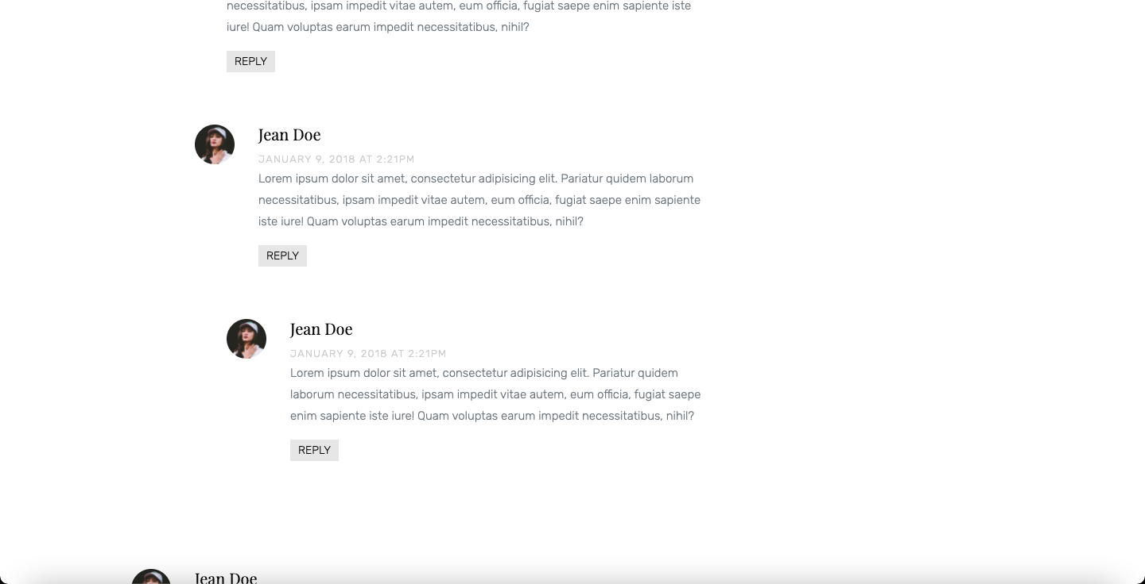

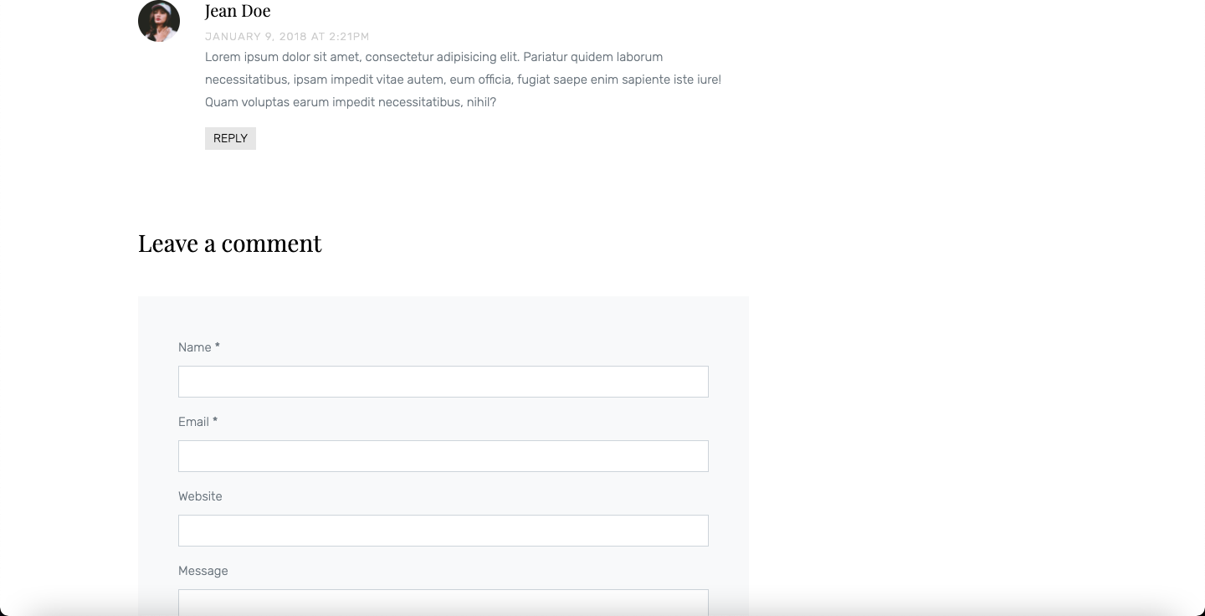

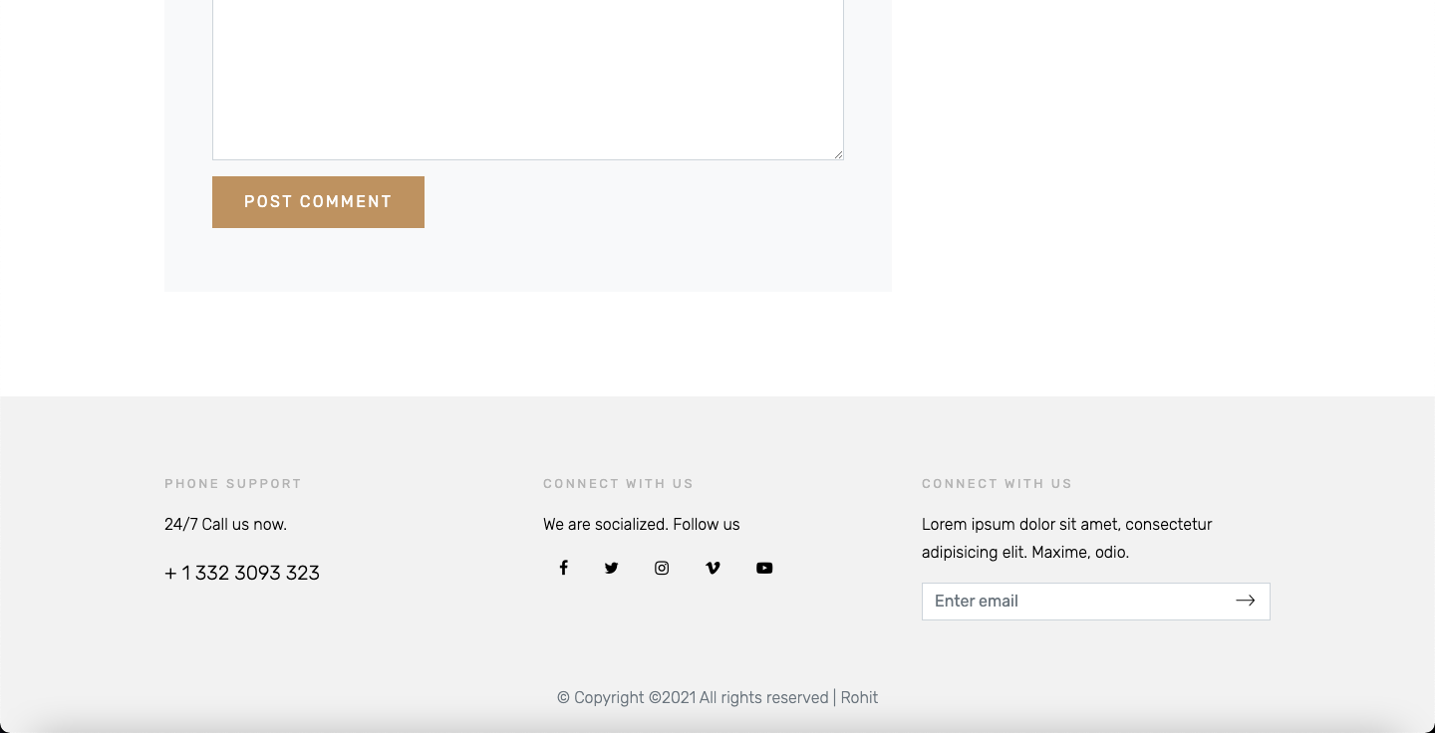

**About**

About contains the information about how this hotel came to be in existence and sheds light on the objectives and goals the hotel and its team focuses to achieve.

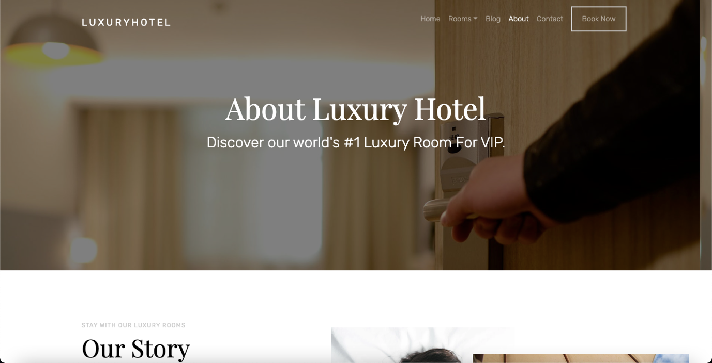

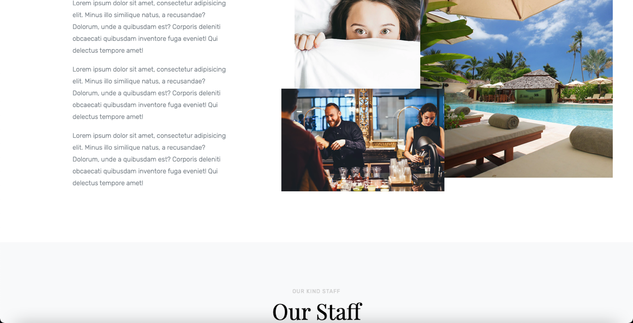

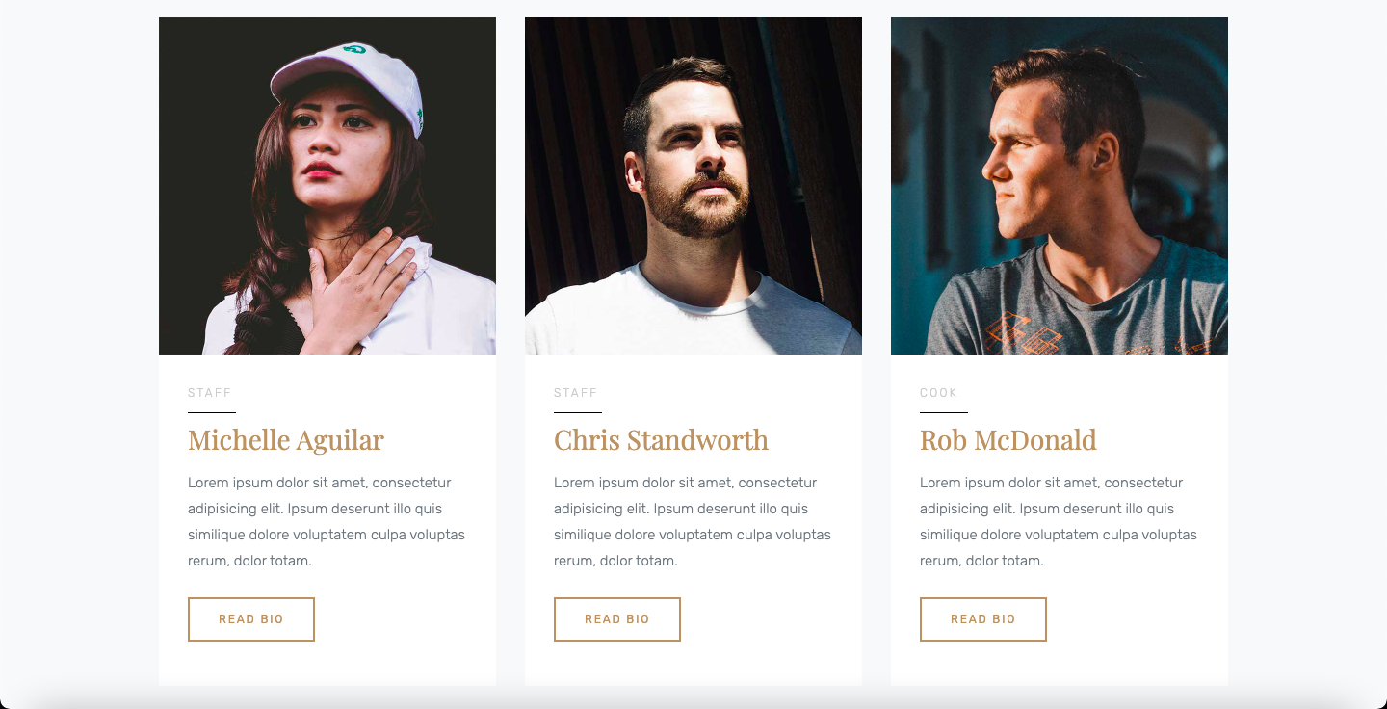

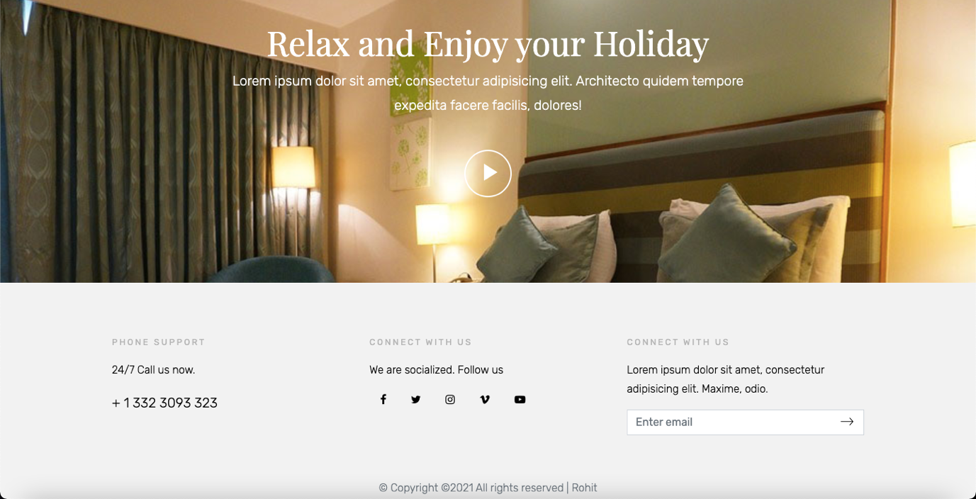

**Contact**

This page contains all the information one might need to contact and to get information required about the hotel like contact number, email address and location.

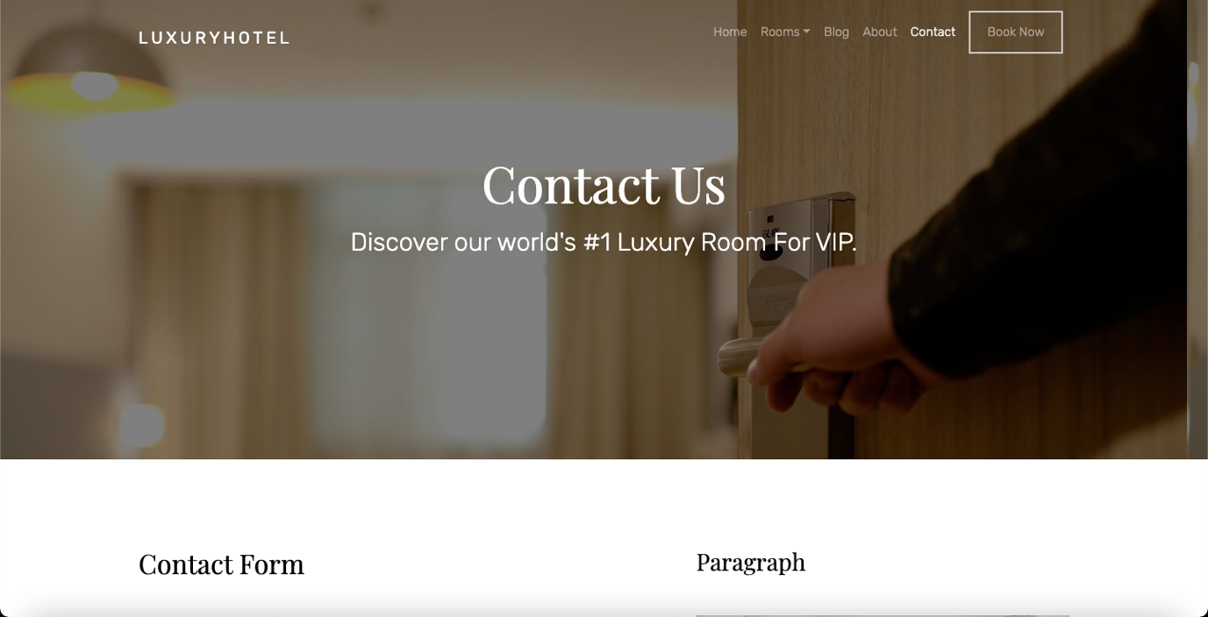

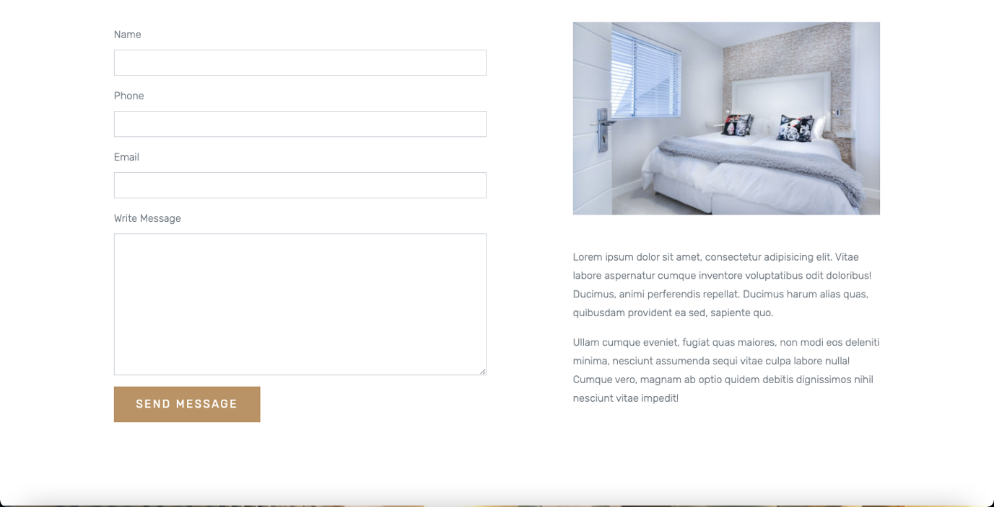

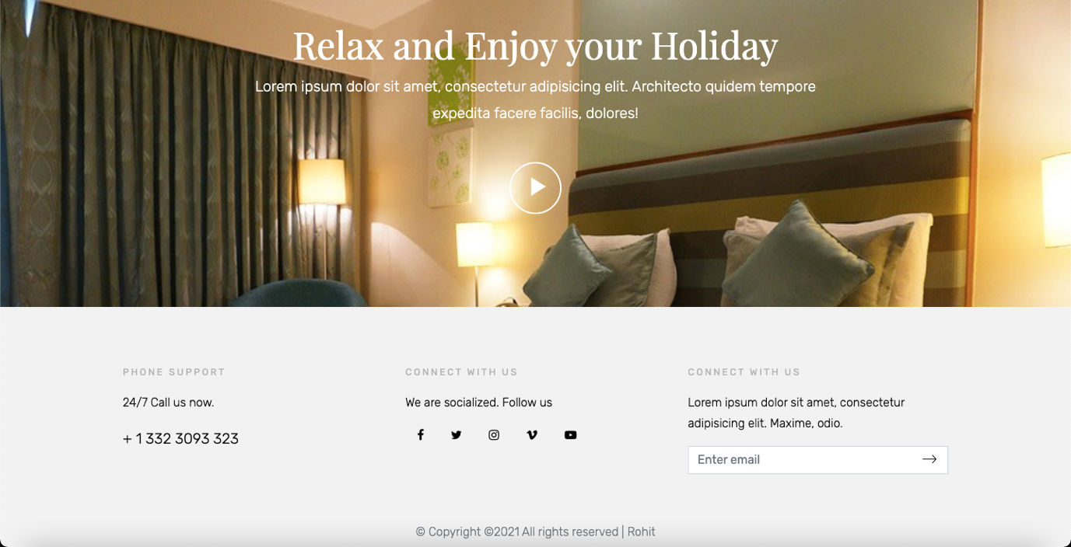

**Book Now**

Book now page provides the user immediate option to book or reserve a room online.

